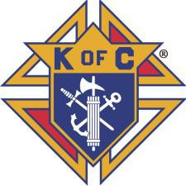

SK RUBEN DELGADO KNIGHTS OF COLUMBUS COUNCIL 11293
SCHOLARSHIP APPLICATION

Application for St. Jude Catholic Church High School Senior Knights of Columbus Council 11293

Eligibility:
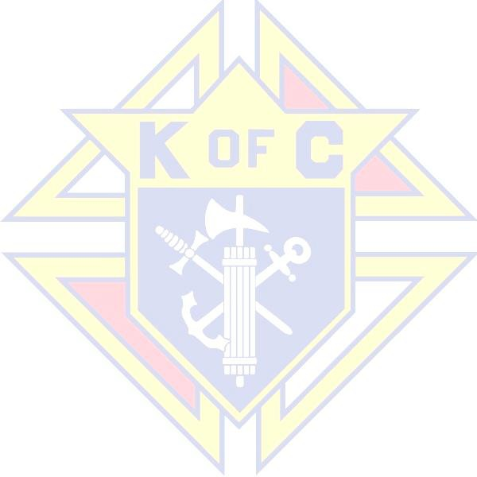

You must be a 2026 Graduating High School Senior from an area high school, parochial or public, or homeschooled, and a participating Catholic that attends St. Jude Catholic Church Parish.

Information:

Scholarships will be awarded to St. Jude members who will be a 2026 graduating High School Senior in good standing and planning to further their education upon graduation. As long as you and/or your family are full time members of the St Jude Parish, attendance may be at a local high school or area High School (i.e., JP II, PoP, MCA) or Home School.

To be eligible, the student must be accepted in an accredited two or four-year University, college, hospital, trade school, or other institution of higher learning. Students are expected to provide proof of acceptance (email, letter, etc.) to the Scholarship Committee prior to award of the scholarship. The Committee will review applications, grades, and present awards prior to the student’s Fall Semester.

- The deadline date to apply for this scholarship is May 17, 2026

To Apply For This Scholarship:

- Complete this application form
- Complete and attach a Short Essay of 200 to 250 words of how your faith has helped you in your life’s journey
- Submit a “Letter of Recommendation” from a teacher, principal, or student counselor, etc.

*The St. Jude Knights of Columbus Scholarship Committee Chairman will accept the applications until 17 May. For any questions concerning this scholarship, please contact Phil Vicknair at 469-881-2137 or phil.vicknair@sbcglobal.net or Joe Shankle at jshankle@soccour.com. Preferred method of submission is electronic via email. Printed copies can also be dropped off at the Parish Receptionist or office in an envelope addressed to Knights of Columbus Council 11293 Scholarship Committee.

COMPLETE THE FOLLOWING (Print please):

- NAME & ADDRESS OF CURRRENT SCHOOL:

- CURRENT Non-Weighted GRADE POINT AVERAGE:

- YOUR NAME (first & last):

- ADDRESS:

- PHONE NUMBER/Email:

- PARENT/LEGAL GUARDIAN (name):

- SACRAMENTS completed at St. Jude:

- What school or extracurricular activities have you participated in and/or what clubs you are a member of? List offices and honors held in each. (please feel free to use additional space if necessary).

- What community service activities have you been involved in and the length of time/dates you performed in each activity? (Example: Volunteered to help with community food pantry, September 2021 through December 2025, etc.)

- What parish activities have you been involved in and the length of time/dates you performed in each activity? (Example: Volunteer Altar Server, September 2021 through March 2025, etc.)

- List the job(s) that you have held. Include tutoring and other work, including for a family member or business, even if not paid.

  - Name of Employer/Address Nature of Work: Length of Employment:

  - Name of Employer/Address Nature of Work: Length of Employment:
  - Name of Employer/Address Nature of Work: Length of Employment:

- College or University applied to/been accepted to: ___________________________________

- What will be your major field of study?

- Complete an essay of 200 to 250 words, stating your desires and reasons you should receive this scholarship. Your essay should include such things as community services, extracurricular activities, collegiate and future goals and objectives. Also include “How your Catholic faith will help you meet your life goals.”

*Your essay must be printed or typed legibly and submitted with this application and attached or emailed

